:

University : Benha University Factulty Of

Engineering-Shoubra

**Name** : Rawan Mohamed Fathy Mohamed

**Date : 1/6/2021**

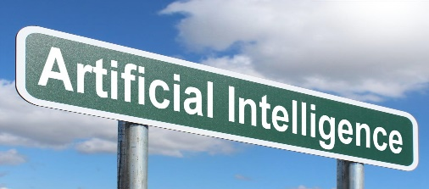****

**TOPIC :**Artificial Intelligence

**Application Brief :**

The term intelligence refers to all the distinct mental abilities that characterize some people and gives them a preference in their performance and behavior in a particular field. The fields of intelligence are unlimited and can not be counted. The specialists in the field have not yet been able to formulate a specific meaning of intelligence , Because of the difference in experts in the classification of forms and types and degrees from one area to another and from one environment to another. It is said that intelligence that is created with the human and develops through learning and acquisition of skills, and what is acquired is developed and developed in a particular area through intensive training programs and skills.

Artificial Intelligence is one of the branches of computer science and one of the main pillars on which the technology industry is based in the current era, and the term artificial intelligence – referred to by the acronym (AI) – can be defined as the ability of digital machines and computers to perform specific tasks that simulate It is similar to that which intelligent beings do;Such as the ability to think or learn from previous experiences or other processes that require mental operations, and artificial intelligence aims to reach systems that have intelligence and act in the way humans behave in terms of learning and understanding.

**Screenshots:**

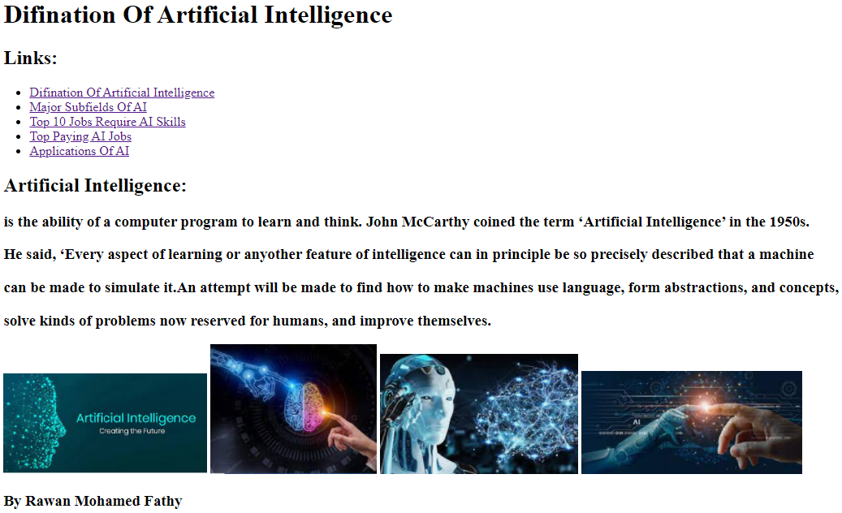

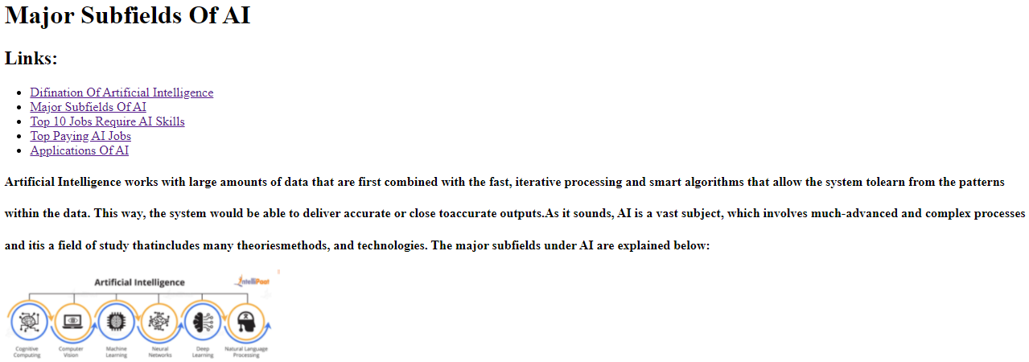

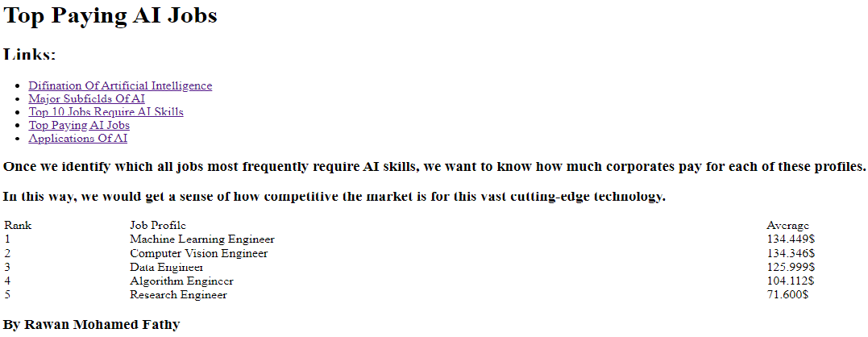

.

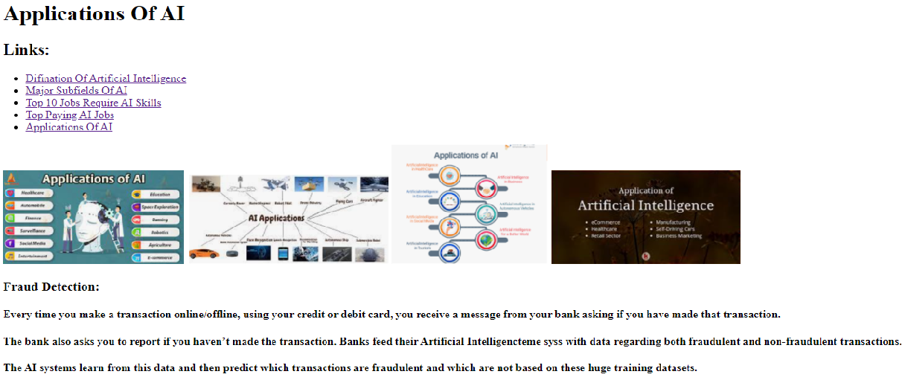

**Source Code :**

